**Assignment – 4**

**-Sai Sree Mithra Sripathi**

* **Using RStudio:**
* **Load “votes.csv” dataset and store it into a local R variable named “votes”**

The attributes in the votes.csv are :

*Attribute Information:*

*1. Class Name: 2 (democrat, republican)*

*2. handicapped-infants: 2 (y,n)*

*3. water-project-cost-sharing: 2 (y,n)*

*4. adoption-of-the-budget-resolution: 2 (y,n)*

*5. physician-fee-freeze: 2 (y,n)*

*6. el-salvador-aid: 2 (y,n)*

*7. religious-groups-in-schools: 2 (y,n)*

*8. anti-satellite-test-ban: 2 (y,n)*

*9. aid-to-nicaraguan-contras: 2 (y,n)*

*10. mx-missile: 2 (y,n)*

*11. immigration: 2 (y,n)*

*12. synfuels-corporation-cutback: 2 (y,n)*

*13. education-spending: 2 (y,n)*

*14. superfund-right-to-sue: 2 (y,n)*

*15. crime: 2 (y,n)*

*16. duty-free-exports: 2 (y,n)*

*17. export-administration-act-south-africa: 2 (y,n)*

***votes <- read.csv("house-votes-84.csv")***

***votes***

***install.packages("arules")***

***install.packages("arulesViz")***

***library(arules)***

***library(arulesViz)***

***vote<-read.transactions("house-votes-84.csv")***

* **Display the content of the “votes” variable by typing the variable name in RStudio.**
* **Display some basic information about the dataset using the “summary” R command.**

***class(vote)***

***inspect(head(vote))***

***str(vote)***

***summary(vote)***

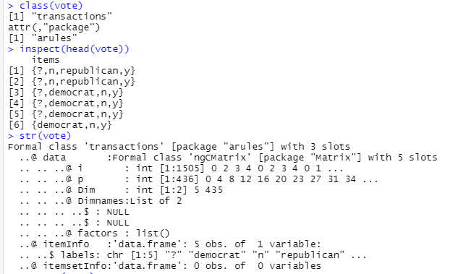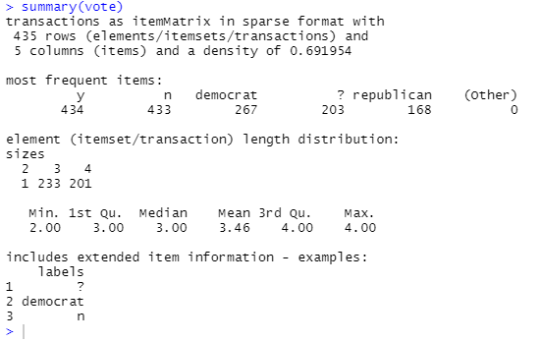

* **Examine the frequency of democrat and republican using the “itemFrequency” R Command. Also plot these frequencies using “itemFrequencyPlot” R command.**

***itemFrequency(vote)***

***itemFrequency(vote[,'democrat'])***

***itemFrequency(vote[,'republican'])***

***frequentItems <- eclat (vote, parameter = list(supp = 0.1, maxlen = 15))***

***inspect(frequentItems)***

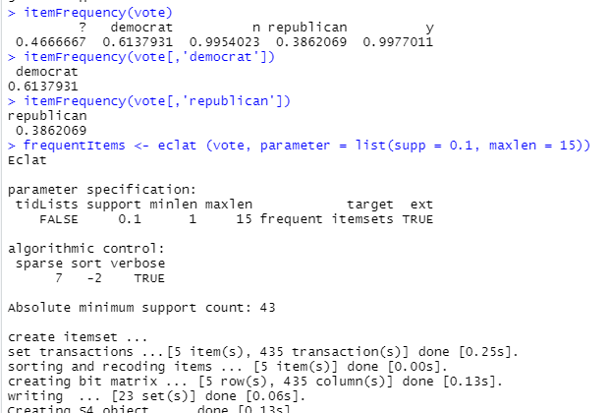

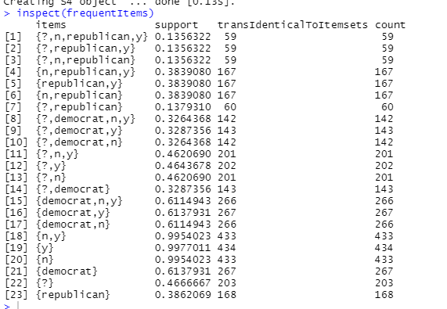

* **Construct association rules using the Apriori algorithm. In this exercise, don’t use default values of support and confidence. Instead, try different combinations and select the one you find more appropriate.**

***image(vote[1:5])***

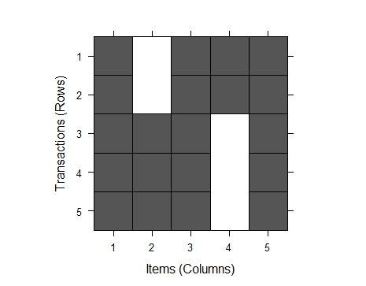

***image(sample(vote,25))***

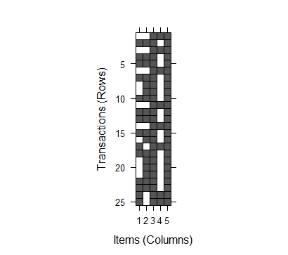

***itemFrequencyPlot(vote, lift="FALSE",type="absolute", main="Item Frequency",horiz="TRUE",popCol="black")***

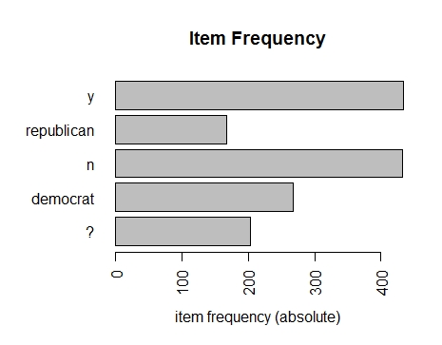

***itemFrequencyPlot(vote, lift="FALSE",type="relative", main="Item Frequency",horiz="TRUE",popCol="black")***

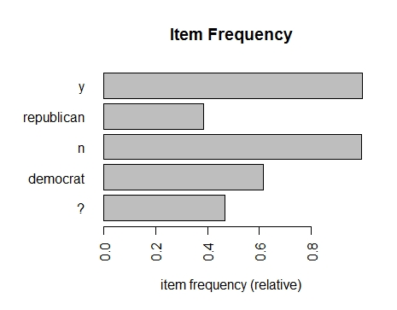

* **Evaluate the association model rule that you constructed using the “summary” R command.**
* **Display all the rules constructed by the model using the “inspect” R command.**

***rule <- apriori(vote)***

***inspect(rule)***

***rules1 <- apriori (vote, parameter = list(supp = 0.07, conf = 0.5))***

***rules <- apriori (vote, parameter = list(supp = 0.001, conf = 0.08))***

***inspect(rules)***

***summary(rules)***

